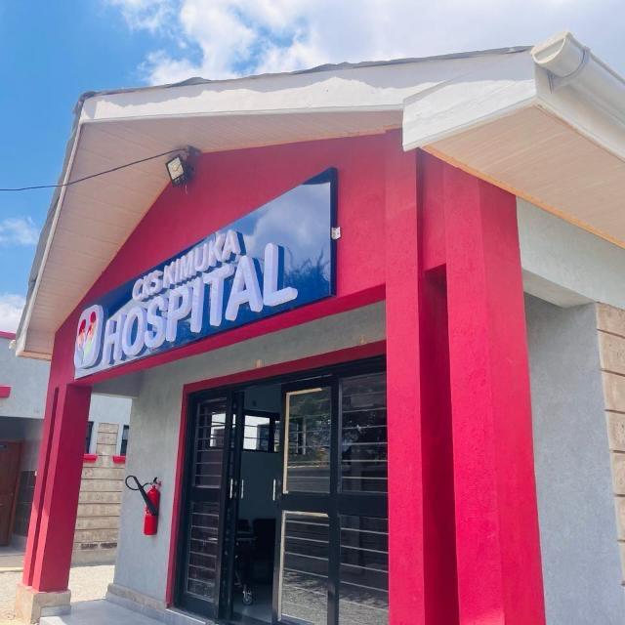 |  | CKS Hospital Kimuka Ltd  Proposal for Partnership and Support  Prepared by: Alice Wala, Administrative Director  Date: JULY 2025

Executive Summary
CKS Hospital Ltd – Kimuka is a 24-hour rural health facility located in Kimuka Village, Ngong, Kajiado County, serving approximately 36000 residents, predominantly from the underserved Maasai community. The hospital plays a vital role in addressing critical healthcare needs including outpatient services, renal care, maternal and child health, and diagnostics-despite significant financial and infrastructure limitations. Climate change and unreliable funding from the Social Health Authority (SHA) further strain service delivery, particularly in emergency response, neonatal care, and dialysis. We are seeking strategic partnerships to help us bridge urgent gaps in medical equipment, staffing, emergency transport, and community outreach. With the right support, we aim to expand our capacity, improve care quality, and build long-term health resilience in one of Kenya’s most marginalized regions

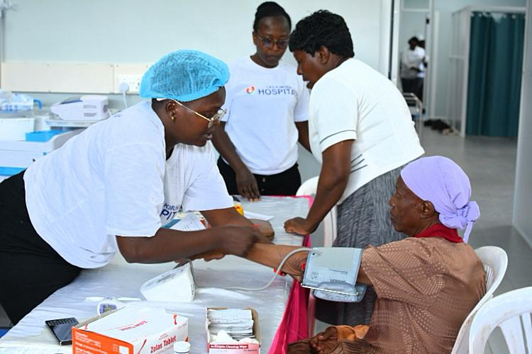

CKS Kimuka Hospital – Report
Month: June 2025
Total Number of Patients: 237
CKS Hospital provides essential primary and emergency medical services every day of the week, including during night hours.
Outpatient Service Statistics (Recent Data):
Daytime Consultations: 209 | 209
Night Consultations: 28 | 28
Under 5 (Male): 15 | 15
Under 5 (Female):41 | 41
Over 5 (Male): 36 | 36
Over 5 (Female): 113 | 113
Total dialysis sessions | 127
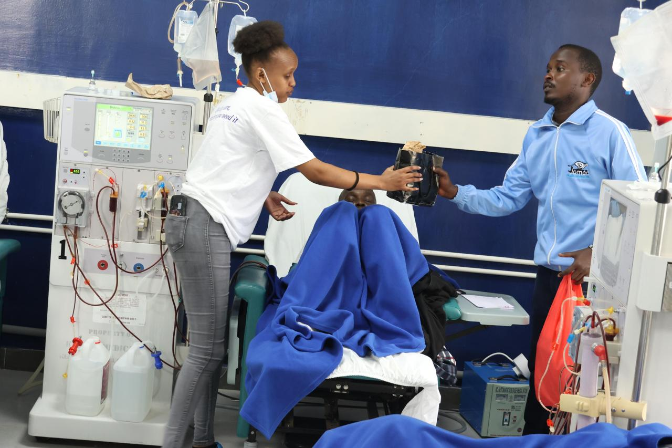
with Mr. Kutit as one of its first beneficiaries dialyzing at our Kimuka Unit

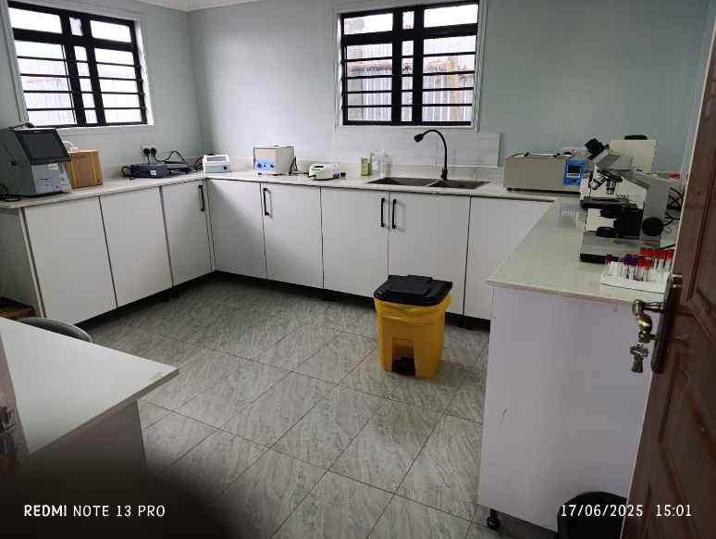

laboratory

ORganizational Background & Legal Status
CKS Hospital Ltd was founded in 2018 by Dr. Jonathan Wala and Mrs. Alice Wala. The initiative began with the establishment of two dialysis units in Nairobi: one in Pangani (12-bed capacity) and another in Buruburu (10-bed capacity). Driven by the vision of expanding access to rural healthcare, the founders responded to the increasing number of patients from Kajiado County traveling over 100 km to Nairobi for dialysis. One such inspiring patient was Mr. Kutit, who received treatment at the Pangani facility for over five years. His perseverance motivated the founders to bring similar specialized services closer to his community.
As a result, CKS Hospital Kimuka was established and opened its doors in October 2024, with Mr. Kutit as one of its first beneficiaries. Since then, it has significantly benefited residents of Kimuka and the surrounding regions by providing accessible renal care and related medical services that are otherwise only available in urban centers.
In response to community needs, CKS launched its Maternity and Child Health Unit in March 2025, offering delivery and maternal-child health services.
To extend its social impact ,the hospital also hosted two major free medical camps.
• In November 2024, a two-week camp served over 500 patients, primarily mothers and children.
• In March 2025, during World Kidney Week, the hospital conducted outreach through a roadshow across several villages in Kajiado, educating residents on kidney health and preventive care.

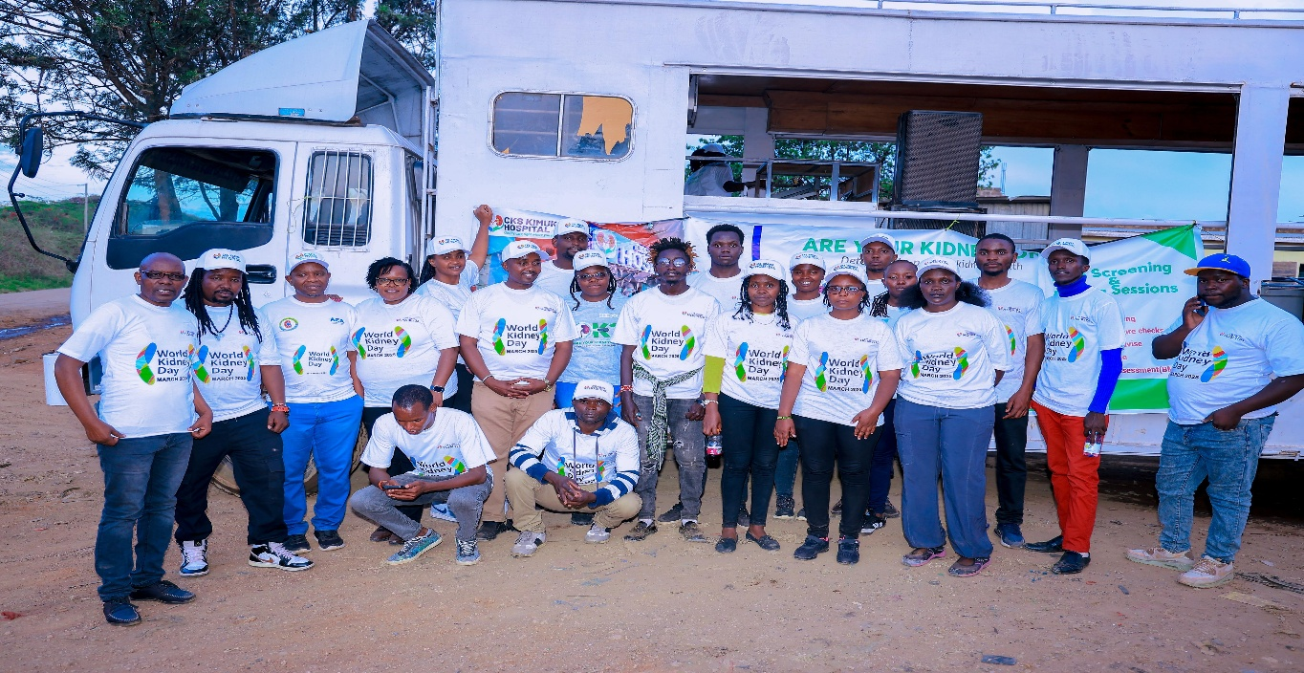
MARCH 2025 WORLD KIDNEY DAY


Free medical camp November 2024

CKS Hospital Ltd is a registered for-profit entity operating under Kenyan law. The hospital maintains partnerships and working relationships with relevant health authorities and is in the process of acquiring further certifications and Memoranda of Understanding (MOUs) with strategic partners to broaden its service delivery and outreach capacity.
The hospital is legally registered under the Kenyan Companies Act,
- Certificate of Incorporation No. PVT-27ULBLD3
- KRA PIN P052388390U.
- SHA FACILITY REG.FID-34-1196056
- MASTER FACILITY CODE 23749

Leadership & Workforce
- Dr. Jonathan Wala – Clinical Director
- Mrs. Alice Wala – Administrative Director

Staff Composition:
- 6 Clinical Staff
- 3 Administrative Staff
- 4 Support Staff
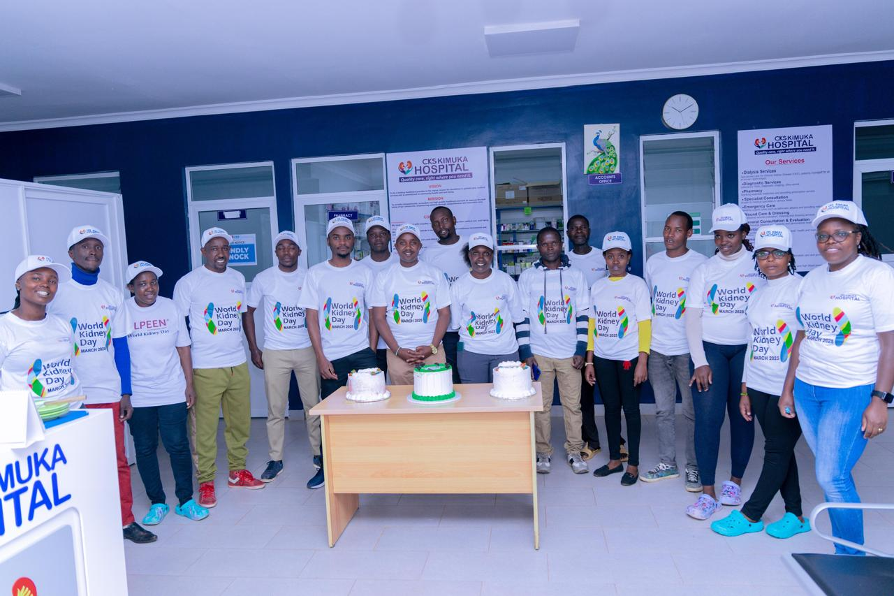
Kimuka team

Vision
To be a leading healthcare provider in the region, known for excellence in patient care, medical services, and commitment to community health and well-being.

Mission
To provide compassionate, accessible, and high-quality healthcare services that improve the well-being of our community, empowering patients through comprehensive and innovative care.

Core Services
  - Outpatient & Emergency Care
Service Offerings
- Accident and trauma care
- General consultation and treatment
- Chronic illness clinics (gynecology, oncology, pediatrics, diabetes, hypertension)
- Specialist referral services

2. Renal Services
- On-site nephrologist for consultations
- Acute and chronic kidney disease management
- Access procedures (catheters, fistulas)
- Emergency and routine dialysis
- Pre- and post-transplant support
- Renal nutrition counseling
- Holistic counseling

3. Maternal & Child Health
- Antenatal and postnatal care
- Normal deliveries
- Post-abortion care
- Immunization
- Family planning (short and long term)
- Triple elimination (HIV, syphilis, hepatitis B)

4. Diagnostic Services
- Ultrasound
- ECG
- Advanced laboratory services

5. Pharmacy Services
- Fully stocked in-house pharmacy operating 24/7
- Supplies both inpatient and outpatient medications
- Stocked with essential drugs, chronic care medication, and emergency supplies
- Offers affordable prices and guidance from licensed pharmacists

6. Specialized Clinics and Outreach
- Diabetes and hypertension clinic
- Nutritional support and food supplements
- Community health outreach and immunization drives

Climate & Health Vulnerability
CKS Kimuka Hospital is situated in a climate-vulnerable region, where extreme weather, food insecurity, and disease outbreaks disproportionately affect women, children, and those with chronic illnesses. To address these challenges, the hospital integrates:
- Health education on nutrition, hygiene, and sanitation
- Seasonal medical outreaches
- Preventive and curative services during health crises
- 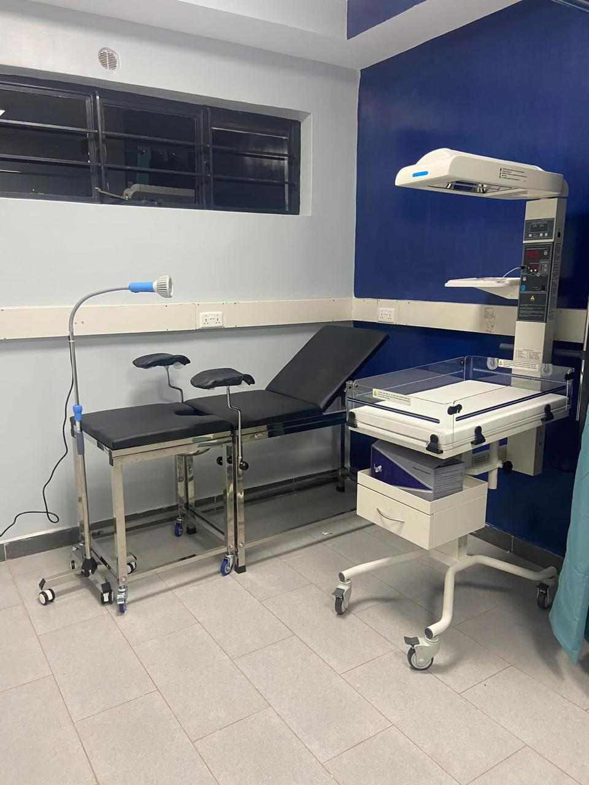
- DELIVEY ROOM

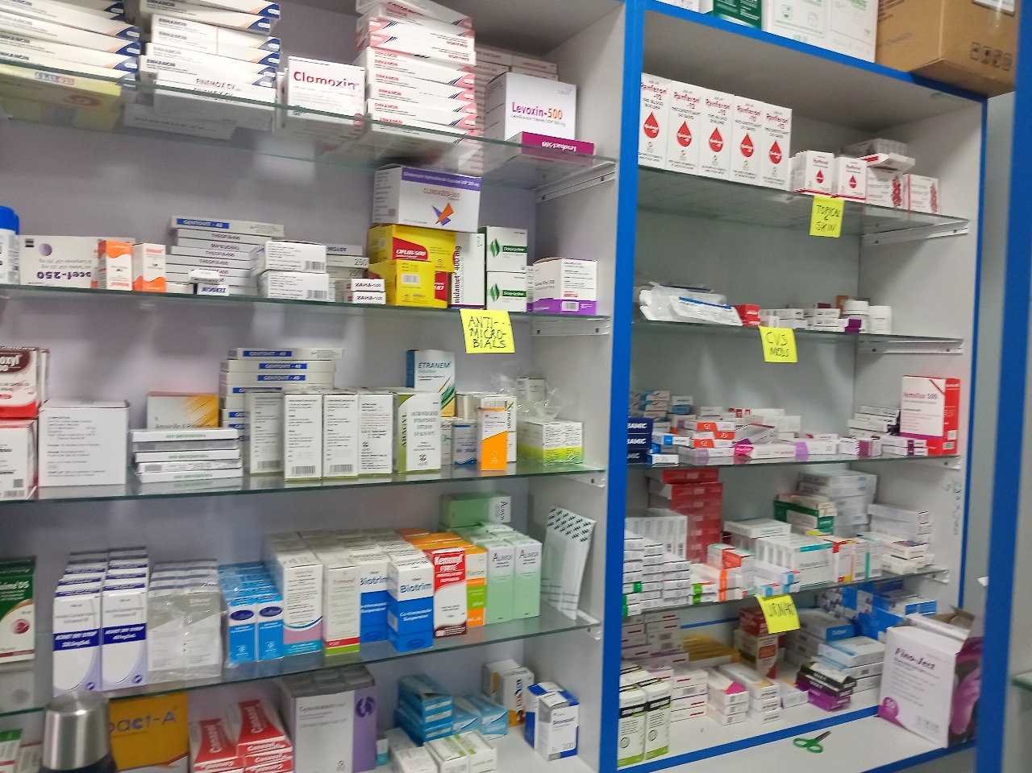
PHARMACY

Challenges & Gaps
Despite its critical role in rural healthcare, CKS Hospital Kimuka faces several challenges:
- Emergency Transport: -no ambulance available for emergency evacuation from the community to the facility and from the facility to higher specialised care.
- Limited Inpatient & Surgical Capacity: Need for ward expansion and fully equipped surgical theatre
- Diagnostic Equipment:
  - Radiology: CT scan, X-ray
  - Laboratory: Biochemistry analyzer, hematology analyzer, ABG analyzer, blood bank fridge, coagulation machine
- Neonatal Unit: Construction and equipping with incubators, resuscitation kits, and oxygen support
- Dialysis Unit: Need for more machines, consumables, and comfortable beds
- Dental & Physiotherapy: Equipment and consumables needed
- Maternal & Child Supplies: Diapers, sanitary pads, hygiene kits, nutritional supplements
- Staffing: Understaffing due to financial constraints, especially affecting night and emergency services
- Infrastructure:
  - Oxygen plant
  - Solar power system
  - Water treatment plant
  - 10 administrative desktops

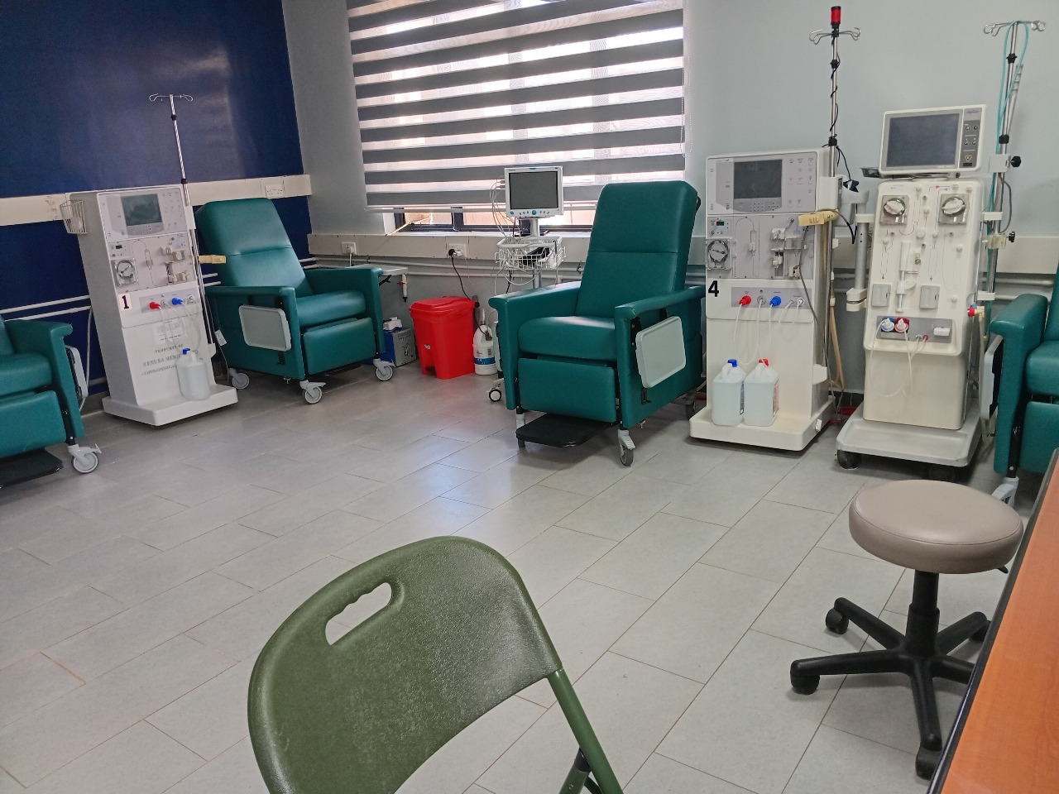
DIALYSIS UNIT

Sustainability Plan
CKS Hospital Kimuka is committed to ensuring that all proposed interventions and healthcare services are sustainable in the long term, both operationally and financially. Our sustainability strategy rests on the following pillars:

1. Local Capacity Building
We prioritize hiring, training, and mentoring local healthcare personnel from within the Maasai community. This not only creates job opportunities but also strengthens community trust and continuity of care.

2. Revenue-Generating Services
While maintaining our core non-profit and subsidized services, the hospital will implement select revenue-generating services (e.g., lab diagnostics, pharmacy, outpatient specialist clinics) to support operational costs and reduce dependency on donor funding.

3. Government Partnerships
We are actively engaged with the Ministry of Health, the county government, and the newly established Social Health Authority (SHA) to integrate more of our services under public healthcare schemes. This includes pursuing capitation and reimbursement for services such as dialysis, maternal care, and outpatient visits.
Our goal is to ensure that essential healthcare services are both accessible to the community and financially sustainable through structured, long-term support from government frameworks. By aligning with national health financing reforms, we aim to enhance service delivery, reduce out-of-pocket costs for patients, and secure ongoing institutional stability.

4. Efficient Resource Management
CKS Hospital emphasizes cost-efficiency through:
- Bulk procurement and supplier negotiations
- Shared utilities and resource pooling across departments
- Investment in solar energy and water harvesting systems to reduce utility costs

5. Community Engagement
Community buy-in and involvement are central to our operations. Through regular health forums and advisory meetings with community elders and women’s groups, we ensure that the services provided are culturally sensitive, relevant, and well-utilized.

6. Strategic Partnerships
We seek long-term collaboration with medical suppliers, philanthropic foundations, and academic institutions for equipment donations, volunteer medical missions, and continued medical education for our staff.

7. Monitoring & Evaluation (M&E)
A robust M&E framework ensures ongoing assessment of service delivery, patient outcomes, and resource utilization. We use this data to adapt our strategy, j and make evidence-based improvements.

Opportunities for Collaboration
We welcome partnerships and support in the following areas:
- Donation of medical equipment and supplies
- Volunteer deployment (medical professionals, technical advisors)
- Technical support for dialysis and maternal care programs
- Outreach and health education campaign support
- Joint research and pilot projects on kidney disease, maternal health, and climate-health impacts

Accountability & Impact
CKS Hospital is committed to:
- Transparency in finances and project outcomes
- Impact tracking through stories, statistics, and visuals
- Capacity building for long-term sustainability
- Respectful community integration of volunteers and external support
Budget
Estimated Budget for Priority Equipment and Infrastructure
Item | Estimated Cost (USD)
Ambulance | $18,000 – $30,000
Obstetric Theater Setup | $25,000
Fully Automated Biochemistry Analyzer | $15,000
5-Part Hematology Analyzer | $12,000
Dialysis Machines (2 units) | $40,000
Solar Power System | $10,000
Newborn Unit Equipment | $8,000
Staff Desktops (10 units) | $5,000
Total Estimated Cost | $143,000+

- Conclusion
At CKS Hospital Ltd – Kimuka, we are deeply committed to delivering life-saving and dignified healthcare. As we expand our dialysis services, enhance maternal care, and respond to climate-related health challenges, we invite you to walk with us. Together, we can build a healthier, more resilient future for the Maasai community and beyond. CKS Hospital kimuka Ltd remains steadfast in its mission to provide affordable, accessible, and quality healthcare to underserved populations in rural Kenya.


Community Testimonial: A Lifeline for Families in Kimuka
"Before the hospital came, we had to walk for hours to get help. When my wife went into labor late at night, we didn’t know where to turn. CKS saved her life. The nurses acted fast, and we were treated with kindness and care. Today, we have a healthy baby girl thanks to them."
— Samuel K., Local Resident, Kimuka
This story reflects the daily reality of many families in the remote areas around Kimuka. With limited access to emergency services, CKS Hospital Kimuka has become a trusted and essential lifeline — especially for maternal and newborn health. By bringing critical care closer to home, the hospital is not just treating patients — it is transforming lives and restoring dignity to rural healthcare.

📞 Contact Information
Email: ckskimuka@gmail.com
Phone: +254 722 649183‬ / +254 753 372814‬‬‬‬‬
Location: Kimuka Trading Center, Suswa Road,
Kajiado West Sub-county, Kajiado County, Kenya

